Following are some main reasons to learn about AI:

With the help of AI, you can create such software or devices

which can solve real-world problems very easily and with

accuracy such as health issues, marketing, traffic issues, etc.

With the help of AI, you can create your personal virtual

Assistant, such as Cortana, Google Assistant, Siri, etc.

With the help of AI, you can build such Robots which can work

in an environment where survival of humans can be at risk.

AI opens a path for other new technologies, new devices, and

new Opportunities.

### **Brief History of AI (1943 - Present)**

* **1943-1952 (Early AI Foundations)**:
  + 1943: Warren McCulloch & Walter Pitts created the first model of artificial neurons.
  + 1949: Donald Hebb introduced Hebbian learning, a key concept in neural networks.
  + 1950: Alan Turing proposed the "Turing Test" to measure machine intelligence.
* **1952-1956 (Birth of AI)**:
  + 1955: Allen Newell & Herbert Simon developed the "Logic Theorist" for mathematical proofs.
  + 1956: John McCarthy coined the term "Artificial Intelligence" at the Dartmouth Conference.
* **1956-1974 (Early Growth & AI Enthusiasm)**:
  + 1966: Joseph Weizenbaum developed ELIZA, the first chatbot.
  + 1972: Japan built WABOT-1, the first intelligent humanoid robot.
* **1974-1980 (First AI Winter)**:
  + AI funding and interest declined due to slow progress and high costs.
* **1980-1987 (AI Revival with Expert Systems)**:
  + 1980: AI research revived with expert systems simulating human decision-making.
  + 1980: The first American AI conference was held at Stanford.
* **1987-1993 (Second AI Winter)**:
  + Funding dropped again as AI systems were costly but inefficient.
* **1993-2011 (Rise of Intelligent Systems)**:
  + 1997: IBM’s Deep Blue defeated chess champion Garry Kasparov.
  + 2002: AI entered homes with Roomba (robot vacuum cleaner).
  + 2006: Companies like Facebook & Netflix adopted AI.
* **2011-Present (AI Boom - Deep Learning & Big Data)**:
  + 2011: IBM Watson won Jeopardy, showcasing natural language processing.
  + 2012: Google launched "Google Now," an AI assistant.
  + 2014: Chatbot Eugene Goostman passed the Turing Test.
  + 2018: IBM’s "Project Debater" argued against human debaters. Google Duplex made AI-powered phone calls.
* **Future of AI**:
  + AI continues to advance with deep learning, big data, and AI-driven applications in major tech companies like Google, Amazon, and IBM.

Types of AI agents

* **Simple Reflex Agent**: Acts only based on current percepts without considering history.
* The Simple reflex agents are the simplest agents. These agents
* take decisions on the basis of the current percepts and ignore
* the rest of the percept history.
* These agents only succeed in the fully observable environment.
* The Simple reflex agent does not consider any part of percepts
* history during their decision and action process.
* The Simple reflex agent works on Condition-action rule, which
* means it maps the current state to action. Such as a Room
* Cleaner agent, it works only if there is dirt in the room.

**Problems for the simple reflex agent design approach:**

o They have very limited intelligence

o They do not have knowledge of non-perceptual parts of the

current state

o Mostly too big to generate and to store.

o Not adaptive to changes in the environment.

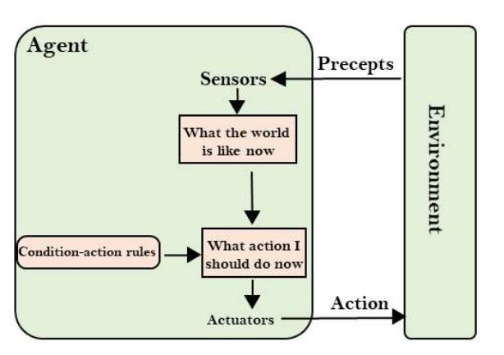

* **Model-based Reflex Agent**: Uses an internal model to handle partially observable environments.
* **Goal-based Agent**: Takes actions to achieve a specific goal.
* **Utility-based Agent**: Chooses actions based on a utility function to maximize performance.
* **Learning Agent**: Improves its performance over time by learning from experiences.

Let's suppose a self-driving car then PEAS representation will be:

Performance: Safety, time, legal drive, comfort

Environment: Roads, other vehicles, road signs, pedestrianActuators: Steering, accelerator, brake, signal, horn

Sensors: Camera, GPS, speedometer, odometer

1. 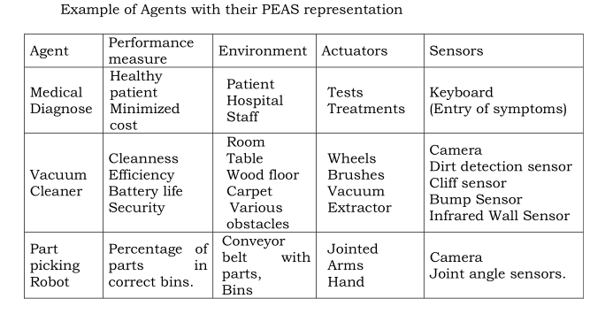

**Fully observable vs Partially Observable:** o If an agent sensor can sense or access the complete state of an environment at each point of time then it is a fully observable environment, else it is partially observable. o A fully observable environment is easy as there is no need to maintain the internal state to keep track history of the world.

**Deterministic vs Stochastic**: If an agent's current state and selected action can completely determine the next state of the environment, then such environment is called a deterministic environment. o A stochastic environment is random in nature and cannot be determined completely by an agent. In a deterministic, fully observable environment, agent does not need to worry about uncertainty.

**Episodic vs Sequential:**

o In an episodic environment, there is a series of one-shot

actions, and only the current percept is required for the action.

o However, in Sequential environment, an agent requires memory

of past actions to determine the next best actions

**Single-agent vs Multi-agent**

o If only one agent is involved in an environment, and operating

by itself then such an environment is called single agent

environment.

o However, if multiple agents are operating in an environment,

then such an environment is called a multi-agent environment.

o The agent design problems in the multi-agent environment are

different from single agent environment.

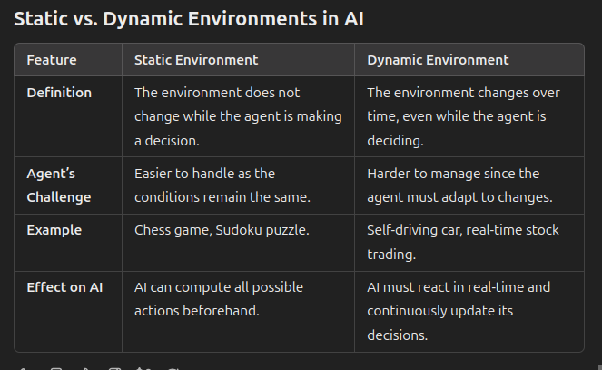

**Discrete vs Continuous:** o If in an environment there are a finite number of percepts and actions that can be performed within it, then such an environment is called a discrete environment else it is called continuous environment. o A chess gamecomes under discrete environment as there is a finite number of moves that can be performed. o A self-driving car is an example of a continuous environment.

**Known vs Unknown** o Known and unknown are not actually a feature of an environment, but it is an agent's state of knowledge to perform an action. o In a known environment, the results for all actions are known to the agent. While in unknown environment, agent needs to learn how it works in order to perform an action. o It is quite possible that a known environment to be partially observable and an Unknown environment to be fully observable.8. Accessible vs Inaccessible o If an agent can obtain complete and accurate information about the state's environment, then such an environment is called an Accessible environment else it is called inaccessible. o An empty room whose state can be defined by its temperature is an example of an accessible environment. o Information about an event on earth is an example of Inaccessible environment.

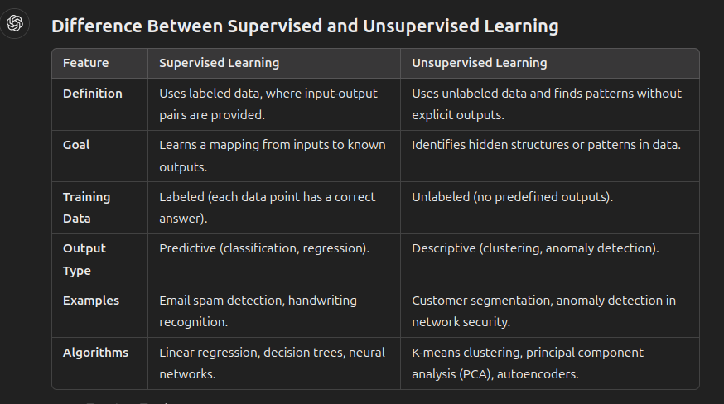

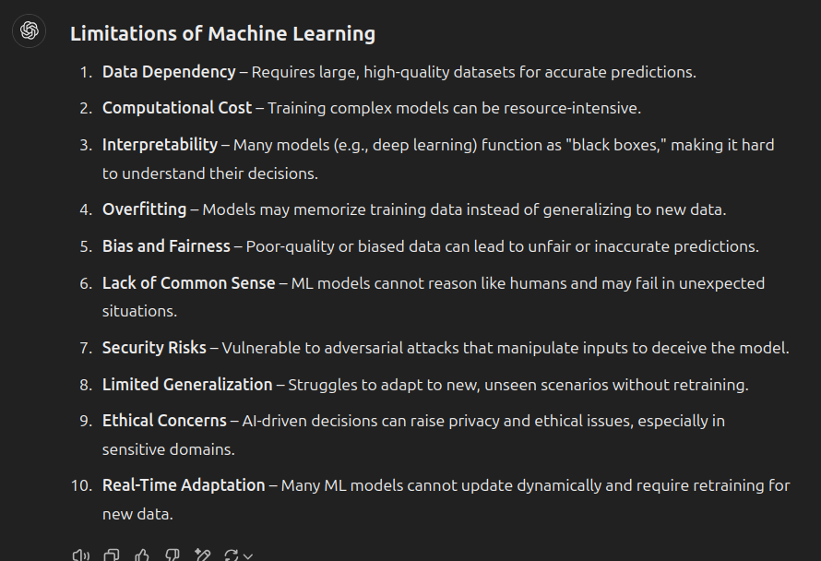

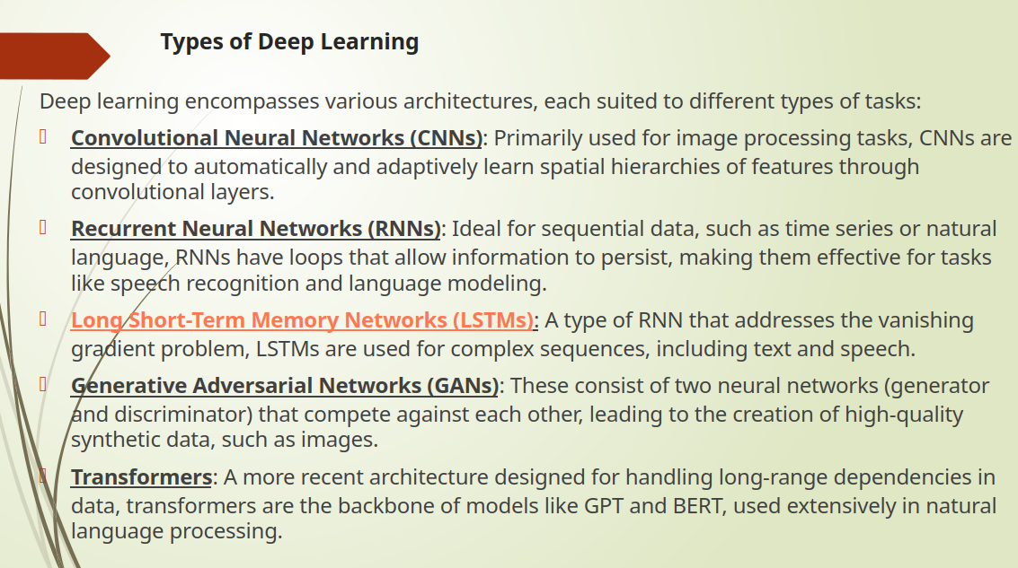

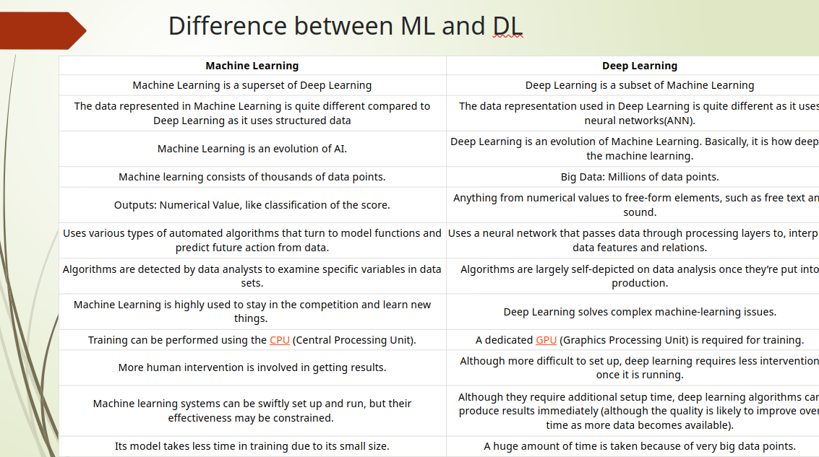

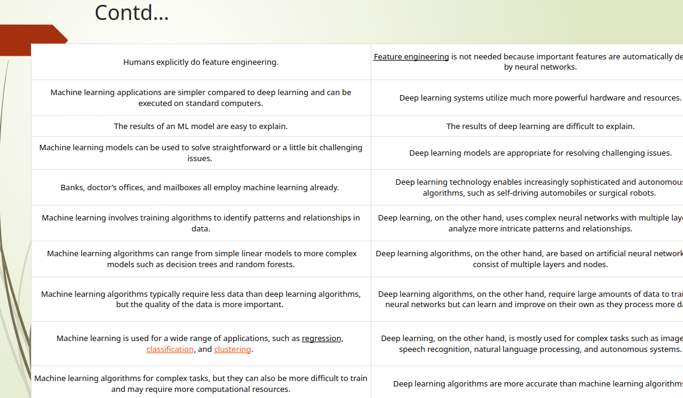

**QUESTIONS WHICH CAN BE ASKED**

**Scenario to decide which agent fits best**

**Write PEAS for somethingg....**